Exploring CLIP: A Vision-Language Model (VLM) for Image Understanding



CodeAddict
Follow
5 min read
·
Apr 1, 2025

In this tutorial, we’ll explore CLIP, a powerful Vision-Language Model (VLM) developed by OpenAI, which bridges images and text for tasks like scene description, classification, and more. We’ll use CLIP alongside YOLOv8 to analyze an image (cat-dog.jpeg), detect objects, match the scene to creative prompts, and annotate the result — all in a Jupyter Notebook.
1. What Is CLIP?
1.1 Definition
CLIP (Contrastive Language-Image Pretraining) is a Vision-Language Model that understands both images and text by learning to associate them in a shared space. Unlike traditional models that require specific training for each task, CLIP can perform “zero-shot” tasks — meaning it can handle new scenarios without retraining.
1.2 What Kind of VLM Is It?
- Multimodal: Combines vision (images) and language (text) processing.
- Pretrained: Trained on 400 million image-text pairs from the internet, making it versatile.
- Zero-Shot Capable: Uses text prompts to guide its understanding, no labeled data needed.
1.3 What Does It Do?
- Takes an image and a list of text prompts (e.g., “A calm scene,” “A wild adventure”).
- Outputs similarity scores, picking the best-matching prompt.
- Enables flexible tasks by simply changing the prompts.
2. What We Do in This Tutorial
We’ll:
- Detect objects in a sample image (cat-dog.jpeg) using YOLOv8.
- Generate a variety of prompts based on those objects (e.g., “A cat and dog sitting quietly”).
- Use CLIP to pick the best prompt.
- Annotate the image with boxes and the selected prompt.
Press enter or click to view image in full size
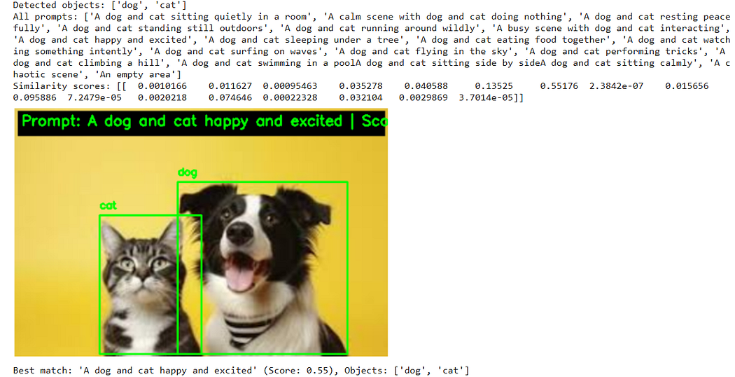
3. Theory Behind CLIP
3.1 Architecture
CLIP has two main components:
- Image Encoder: A Vision Transformer (ViT) or a ResNet variant (e.g., ViT-B/32 in this tutorial).
- Splits an image into patches (e.g., 32x32), processes them with Transformer layers, and outputs a single 512-dimensional vector.
- Text Encoder: A Text Transformer
3.2 Contrastive Learning
- Training Goal: Make vectors of matching image-text pairs (e.g., a dog photo and “A dog”) similar, and non-matching pairs dissimilar.
Method: Uses contrastive loss:
- For a batch of N pairs, it maximizes the cosine similarity of correct pairs while minimizing it for the N² — N incorrect pairs.
4. What Can We Do with CLIP?
- Image Classification: Label images with custom categories (e.g., “happy” vs. “sad”) using prompts.
- Scene Description: Match images to detailed narratives (e.g., “A cat napping on a sunny porch”).
- Visual Question Answering: Answer questions about images (e.g., “Is it raining?”).
- Image Search: Find images by text queries.
- Content Moderation: Detect inappropriate content with text prompts.
5. Implementation
- Setup: Install dependencies:
pip install torch torchvision ultralytics git+https://github.com/openai/CLIP.git opencv-python numpy pillow matplotlib
- Import Libraries
Get CodeAddict’s stories in your inbox
Join Medium for free to get updates from this writer.
Subscribe
import cv2
import numpy as np
import torch
from ultralytics import YOLO
import clip
from PIL import Image
import matplotlib.pyplot as plt
%matplotlib inline
print("Libraries imported successfully!")
- Load Models
def load_clip_model():
model, preprocess = clip.load("ViT-B/32", device="cuda" if torch.cuda.is_available() else "cpu")
return model, preprocess
def load_yolov8_model():
return YOLO("yolov8m.pt")
clip_model, preprocess = load_clip_model()
yolo_model = load_yolov8_model()
print("Models loaded: CLIP (ViT-B/32) and YOLOv8 (medium)")
- def load_clip_model(): Function to load CLIP.
- clip.load(“ViT-B/32”, …): Loads Vision Transformer (base, 32x32 patches), returns model and preprocessing function.
- Generate Prompts
def generate_prompts(detected_objects):
if not detected_objects:
return ["An empty scene with no objects"]
base_prompts = [
"A {objects} sitting quietly in a room",
"A calm scene with {objects} doing nothing",
"A {objects} resting peacefully",
"A {objects} standing still outdoors",
"A {objects} running around wildly",
"A busy scene with {objects} interacting",
"A {objects} jumping in excitement",
"A {objects} sleeping under a tree",
"A {objects} eating food together",
"A {objects} watching something intently",
"A {objects} surfing on waves",
"A {objects} flying in the sky",
"A {objects} performing tricks",
"A {objects} climbing a hill",
"A {objects} swimming in a pool"
]
unique_objects = set(detected_objects)
object_str = " and ".join(unique_objects)
return [prompt.format(objects=object_str) for prompt in base_prompts]
test_objects = ["cat", "dog"]
prompts = generate_prompts(test_objects)
print("Generated prompts (sample):", prompts[:5], "...and", len(prompts)-5, "more")
- base_prompts = […]: 15 diverse prompts.
- unique_objects = set(…): Removes duplicates.
- object_str = …: Joins objects (e.g., “cat and dog”).
- return […]: Formats prompts.
- test_objects = …: Tests with “cat” and “dog”.
- prompts = …: Generates prompts.
- Extract Image Features and Detect Objects
def extract_image_features(image_path, clip_model, preprocess, yolo_model):
image = cv2.imread(image_path)
image_rgb = cv2.cvtColor(image, cv2.COLOR_BGR2RGB)
results = yolo_model(image_rgb, verbose=True)
detected_objects = [results[0].names[int(box.cls)] for box in results[0].boxes]
print("Detected objects:", detected_objects)
image_pil = Image.fromarray(image_rgb)
image_tensor = preprocess(image_pil).unsqueeze(0).to(clip_model.logit_scale.device)
with torch.no_grad():
image_features = clip_model.encode_image(image_tensor)
return image_features, detected_objects, image_rgb, results[0].boxes
image_path = "cat-dog.jpeg"
image_features, detected_objects, image_rgb, boxes = extract_image_features(image_path, clip_model, preprocess, yolo_model)
plt.figure(figsize=(10, 6))
plt.imshow(image_rgb)
for i, box in enumerate(boxes):
x1, y1, x2, y2 = map(int, box.xyxy[0])
plt.plot([x1, x2, x2, x1, x1], [y1, y1, y2, y2, y1], 'g-')
plt.text(x1, y1-10, f"{detected_objects[i]}", color='green')
plt.axis('off')
plt.show()
- image = cv2.imread(…): Loads your image.
- image_rgb = …: Converts to RGB.
- results = yolo_model(…): Detects objects.
- detected_objects = …: Extracts names.
- print(…): Shows objects.
- image_pil = …: Prepares for CLIP.
- image_tensor = …: Preprocesses and adds batch dimension.
- image_features = …: Gets 512D vector.
Output:
Press enter or click to view image in full size
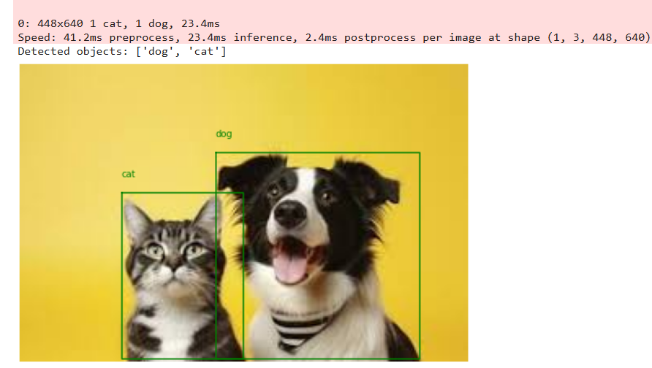
- Match Scene to Prompts
def match_scene(image_features, detected_objects, clip_model, query_prompts):
device = clip_model.logit_scale.device
text_tokens = clip.tokenize(query_prompts).to(device)
with torch.no_grad():
text_features = clip_model.encode_text(text_tokens)
similarity = (image_features @ text_features.T).softmax(dim=-1).cpu().numpy()
best_prompt_idx = similarity.argmax()
best_score = similarity.max()
print("All prompts:", query_prompts)
print("Similarity scores:", similarity)
return query_prompts[best_prompt_idx], best_score, detected_objects
prompts = generate_prompts(detected_objects)
query_prompts = prompts + ["A chaotic scene", "An empty area"]
best_prompt, score, objects = match_scene(image_features, detected_objects, clip_model, query_prompts)
print(f"Best match: '{best_prompt}' (Score: {score:.2f})")
Output: (CLIP picks the best prompt.)
Similarity scores (first 5 and last 5): [[ 0.0033512 0.034393 0.00050592 0.32129 2.3246e-06 0.0014639 3.612e-05 2.9802e-07 0.0028229 0.0033512 5.9605e-08 3.9637e-05 3.3379e-06 9.8944e-06 2.3842e-07 0.62891 0.0039787]] ... [[ 0.0033512 0.034393 0.00050592 0.32129 2.3246e-06 0.0014639 3.612e-05 2.9802e-07 0.0028229 0.0033512 5.9605e-08 3.9637e-05 3.3379e-06 9.8944e-06 2.3842e-07 0.62891 0.0039787]]
Best match: 'A chaotic pet scene' (Score: 0.63)
- text_tokens = …: Tokenizes prompts.
- text_features = …: Gets 512D vectors.
- similarity = …: Computes scores.
- best_prompt_idx = …: Finds best match.
- best_score = …: Gets score.
- prompts = …: Generates prompts.
- query_prompts = …: Adds static prompts.
- best_prompt, … = …: Matches scene.
- Annotate and Save Image
def annotate_image(image_rgb, boxes, best_prompt, score, objects):
scale_factor = 2
image_rgb_resized = cv2.resize(image_rgb, None, fx=scale_factor, fy=scale_factor, interpolation=cv2.INTER_LINEAR)
image_bgr = cv2.cvtColor(image_rgb_resized, cv2.COLOR_RGB2BGR)
for i, box in enumerate(boxes):
x1, y1, x2, y2 = [int(coord * scale_factor) for coord in box.xyxy[0]]
label = objects[i]
cv2.rectangle(image_bgr, (x1, y1), (x2, y2), (0, 255, 0), 2)
cv2.putText(image_bgr, label, (x1, y1-10), cv2.FONT_HERSHEY_SIMPLEX, 0.5, (0, 255, 0), 2)
text = f"Prompt: {best_prompt} | Score: {score:.2f} | Objects: {', '.join(objects)}"
font_scale = 0.7
thickness = 2
text_size, baseline = cv2.getTextSize(text, cv2.FONT_HERSHEY_SIMPLEX, font_scale, thickness)
text_width, text_height = text_size
padding = 10
rect_height = text_height + 2 * padding
cv2.rectangle(image_bgr, (5, 5), (image_bgr.shape[1] - 5, 5 + rect_height), (0, 0, 0), -1)
text_x = 10
text_y = 5 + text_height + padding // 2
cv2.putText(image_bgr, text, (text_x, text_y), cv2.FONT_HERSHEY_SIMPLEX, font_scale, (0, 255, 0), thickness)
output_path = "/workspace/test/10_vlm/pet_analysis.jpg"
cv2.imwrite(output_path, image_bgr)
return cv2.cvtColor(image_bgr, cv2.COLOR_BGR2RGB)
annotated_image = annotate_image(image_rgb, boxes, best_prompt, score, objects)
plt.figure(figsize=(12, 8))
plt.imshow(annotated_image)
plt.axis('off')
plt.show()
print("Annotated image saved to '/workspace/test/10_vlm/pet_analysis.jpg'")
Output:
Press enter or click to view image in full size
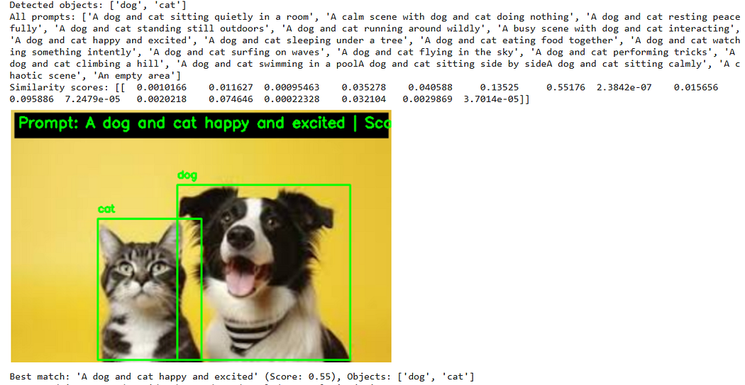

Vlm

Clip

Visionlanguagemodel

Zeroshotlearning

